XYZ Translation, Inc.

To: Joe Ford, Chief Information Officer
From: Gael M, IT Support Agent
Date: February 7, 2023
Re: Integration of Azure to Microsoft Teams

Summary: Please find attached my implementation strategy to integrate a cloud-based data visualization and monitoring platform to Microsoft Teams.
Background: With the rise of hybrid work, cloud-based collaboration technologies build on the momentum they had acquired during the pandemic to become one of the highest performing markets of 2022. Dropbox is one of the cloud-based file sharing and collaboration tools used by localization teams, yet this software does not allow users to create and manage work items. Therefore, it was necessary to come up with a deployment plan to integrate Microsoft Teams to Azure to secure and monitor access to our infrastructure.
Details: My report includes an implementation plan to guide the DevOps Team on installing, monitoring, as well as maintaining Teams past the integration process. I’ve also developed a table comparing Microsoft Teams’ features to those of Slack to make informed decisions.
I included a series of recommendations from various subject expert matters about securing Teams through Azure Directory, as well as steps to create and operate applications via Azure Virtual Network.
On a side note, I gathered details on how to set up a virtual machine, and automate processes with Azure Logic App.
Action: Please take a look at the attached formal report and approve my proposal for an implementation plan as well as the conditions required to successfully integrate Teams to Azure.

Sincerely,
Gael Mbala
IT Support Agent
(425) 233-0183 gmbala@xyztranslation.com

XYZ Translation, Inc.

Comprehensive Plan to Integrate Microsoft Teams to Azure

Formal Report

Gael Mbala
IT Support Agent

This report explores the implications of integrating Microsoft Teams to Azure as well as the monitoring access to infrastructure. help deliver value to customers and shareholders. amid the rise of hybrid work over the past 2 years.

Table of Contents
Executive Summary 1
Introduction 4
Background 5
Discussion 6
Security & Azure Sentinel 12
Conclusions 13
Recommendations 15
References 16
Appendix 22

Introduction
Background
The hybrid work model has revolutionized our perception of the workplace. While many companies are still working on crafting a post-Pandemic plan, others have invested in collaboration tools to bring employees together and optimize innovation. With flexibility and work-life balance being expected by over 70% of employees, the unexpected transition to video conference and screen share technologies re-affirmed the proliferation of Microsoft Teams, Zoom, Webex, and similar software on our work computers (Pratt, 2023).
I had no remote work experience prior to the pandemic, so it was challenging to get used to attending training sessions via Teams or I make a note of phone numbers on Whiteboard via an API. Any other time we relied on the “Comment” function on SharePoint to keep ourselves up to date with the most recent changes made on projects. Similarly, cloud-based collaboration technologies build on the momentum they had acquired during the pandemic to become one of the highest performing markets of 2022. Business leaders are investing in IT technology by adding more end-user contact channels to facilitate collaboration both on-site and remotely.
Although the exchange of technical information has remained unchanged over the past 2 years, collaborative creative tasks have been flagged as the least innovative ones for hybrid employees. This implies that collaboration tools played a role in weakening employees’ ties to the organization since only projects can be executed with remote participants with little to no supervision thanks to project management and collaboration tools (Trevor & Holweg, 2022).
For many hybrid workers, the ideal role must include technologies that allow them to “replicate” the digital experiences that happen more in person to prevent falling into the proximity bias model and cause friction between onsite and hybrid employees. Conversely, as many organizations struggle to retain employees, Microsoft Teams has been doing a great job at highlighting employees’ performance and increase their visibility. The software also makes it easier for remote and hybrid workers to connect with mentors for growth opportunities (Groysberg et. al., 2022). However not all industries require an in-person presence. For instance, the global market for language technology is projected to increase over the next few years as organizations are looking to connect with a global audience in local languages. And this was exacerbated by a demand for live interpreters to assist limited English speakers at hospitals, courtrooms, conference rooms, etc. While the transition from in-person to remote was abrupt but successful, XYZ emerged as a winner in this “back to office” battle where various businesses are losing on talent for failing to take employees’ professional and personal requirements into account. This has not only been detrimental to customer satisfaction, but the lack of flexibility continues to hurt innovation (Trevor & Holweg, 2022).
Hybrid work is here to stay. More than 80% of employees believe a good work-life balance is essential to maintaining a healthy lifestyle. However, many organizations have struggled to meet work flexibility, causing employees to seek new positions. To resolve this issue, integrating Azure DevOps into Microsoft Team is crucial for remote and hybrid employees to achieve a work-life balance, and increase productivity.

Overview of current cloud infrastructure

As data has become fundamental to optimizing business value, so has the demand for cloud-based storage. XYZ Translation has billion of files and projects currently stored in unscalable servers that can only be accessed in one location (What is Data Center Virtualization?: Glossary, n.d.). Rather than outsourcing to third-party providers, moving data to the cloud comes with increased agility, cost-savings, and efficiency.
As it stands now, employees have been storing statements of work, service agreements, transcripts, personal notes in Dropbox. Then the decentralized storage provider keeps a copy of the file’s encryption key as soon as it’s uploaded. This makes confidential information vulnerable to data breaches as opposed to Azure’s “Zero Knowledge Encryption” system in which the encryption is only accessible by users (Nesbo, 2021).
Since its launch in 2008, Azure has become the go cloud computing service for accommodating workloads via VM’s (virtual machines). These capabilities are vital to hosting applications and maintaining antivirus programs, including the legacy ones like Tableau and Confluence.

Enterprise Architecture
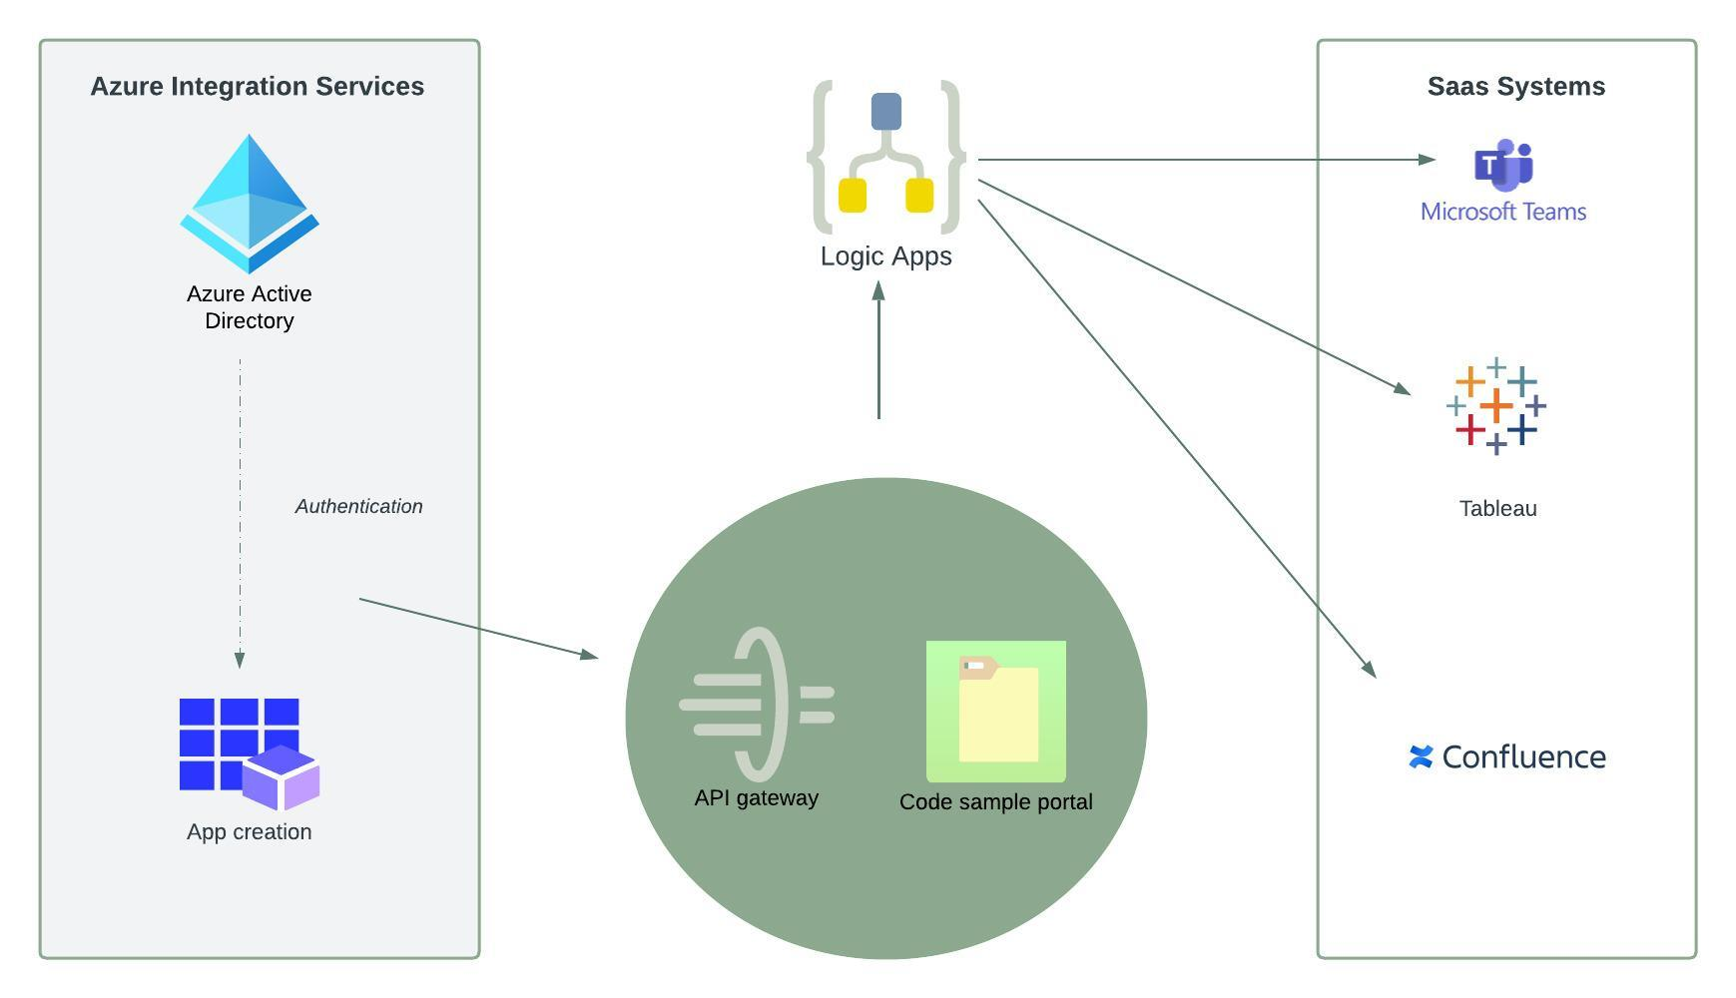

Azure Logic Apps make it possible for apps to run in a cloud-native environment by orchestrating API calls through connectors. This mechanism allows IT administrators to configure, manage and monitor critical data (N. Blair, personal communication [email], February 10, 2023) However, because the platform is serverless, low latent calls can easily be dropped, which this makes it challenging to deploy or integrate apps they are put in the same region as API management along with backend SaaS systems. As opposed to Power Automate, Logic Apps can be monitored at both DevOps and admin level using the Application Life cycle management (ALM) tools including code management, version control, and project planning. This hints that not much work will be needed from the non-IT employees to run queries and extract work items as the workflow is headed towards automation.

On the other hand, as the “BYOD” (Bring your Own Device) phenomenon went from being taboo to being encouraged over the past few years, the increased exposure of corporate data to cyberattacks poses a security risk not just to users’ identities but also the network infrastructure especially with frequent logins from unfamiliar devices. That said, the 3 main capabilities of API gateways are as follows:
- Mobile infrastructure security – This helps prevent unauthorized access and DOS attacks

- Centralized location for running API program – Essential to monitoring access to communication channels between the API gateway and backend systems

- Flexibility to integrate applications across any environment on ISV partner environments
Azure Logic Apps, along with its ultra-secure API management systems are essential to enabling scalable, secure, and reliable applications. These components provide caching and paging as well as a developer portal to store code.
Azure Active Directory & User Access
In a similar fashion, developers, customers, and stakeholders can combine more than 3,000 services delivered on the Azure’s mobile app and get integrated support on the go, anytime. Another advantage of integrating Microsoft Teams to Azure is that IT admins can manage access to organizational resources and require Two-factor authentication using the single sign-on system, and get unique analytical insights straight from Power BI and Teams’ channels on a subscription basis using Microsoft 365. Luckily, AD also allows for a more decentralized repartition of resource groups where the Global Administrator manages all access to critical information while the Service administrator on the other hand pass on administrator privileges to non-administrators including but not limited to managing resources and creating VM’s.
According to N. Blair (personal communication, [email] February 10, 2023), access requests are reviewed via both Azure and MyAccess. While the latter have been predefined and does not require maneuvering at a DevOps-level, resources within Azure can be managed for a specified amount of time of using the Just in Time feature (N. Blair, personal communication, February 10, 2023).
Basic Considerations when Configuring Azure AD
- Operating System
- Using an open-source image will reduce costs.
- Storage
- For archiving data, storing in HDD will reduce costs, but for data that needs to be readily accessed and processed an SDD solution may be better.
- Processing power
- This should be tailored to the tasks or operations needed by the virtual machine. You wouldn’t want machines running expensive GPU units for instance if regular CPU processing is all that is needed.
- Intra-virtual machine communication
- Setting up appropriate network security groups is vital to maintaining an agile and scalable cloud environment. This means global administrators can limit permissions by setting up appropriate IP whitelisting to ensure that threat actors don’t interact with the infrastructure in case Microsoft Teams is compromised.
Azure Storage & Data Factory
API connectors offer users the opportunity to pipeline data both on-premises and in the cloud and store them into a repository. As E. Boyd (Q&A, January 26, 2023) suggested, users can easily clean up or transform data into a full-blown activity from data sources all the way to visualizing those using business intelligence. In addition, activities are scheduled in terms of start and end dates. This means transformations and control flows can be found in the “Activity Configuration” section of the data integration tool.

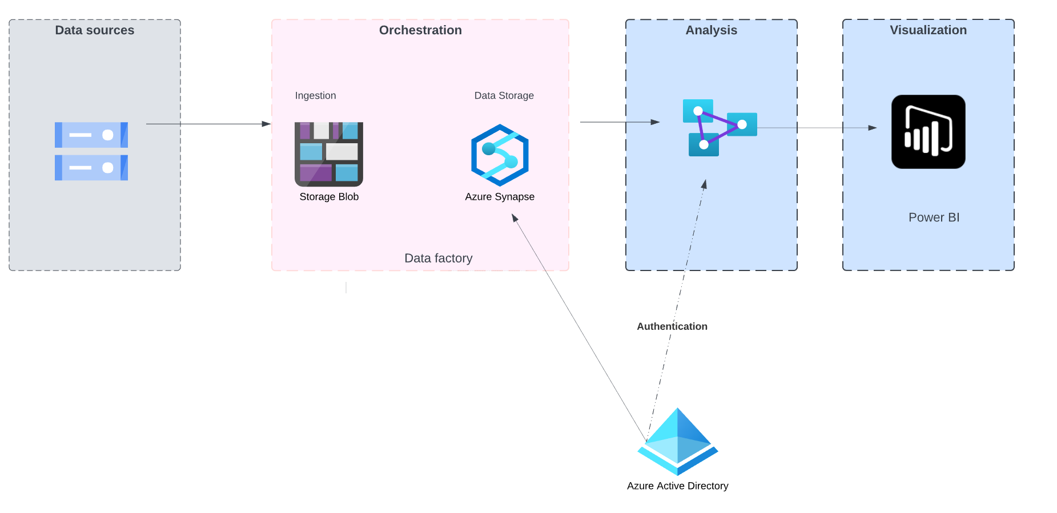

 | Microsoft Teams | Slack
Features | - Extensive web conferencing capabilities  - Easy integration with other Microsoft and partner apps  - Fast searching for information | - Seamless integration with other tools  - Task automation through IFTTT technology  - Quick Switcher option to easily navigate through channels using a shortcut command
Pricing | $12.50/month | $12.50/month
Productivity | - Users can schedule or modify meetings on the platform without having to open a separate app. | - Allows users to save important messages on the “Saved items” list for future reference.
User Interface | - Content pane allows for easy calendar, channel, and access | - Responsive mobile app  - Multiple status logos to set expectations
Workflow & Bots | - Workflows triggerable from conversations  - Knowledge base built upon FAQ pages to manage tier one requests sent to IT | - Integrated “Slackbot” helps with reminders and notetaking to optimize productivity
Security | - Encryption of data in transit via Active Directory  - Every data is backed up in Azure | - Advanced identity management via SSO  - Active Directory sync with Okta and Ping Identity

Conclusions
Logic App workflows make it easier for business processes to be visualized and automated hierarchically.
Users can create work items from conversations in the channel and share them with teammates using the messaging extension.
Azure has more certifications than any Cloud provider.
The Azure Active Directory’s “Connect” feature allows users to access confidential information using the same credentials both on-premises and in the cloud.
Recommendations
Enhancing cross-functional communication to accelerate deployment
Build a team that champions the integration of Azure with Teams
Training employees on creating and managing work items using Azure Boards
Identifying new opportunities caused by the deployment of cloud solutions

References
Altaiar, H., Babel, I., Lee, J., et al. (2022). The Developer's Guide to Azure. Redmond; Packt Publishing.
Basic enterprise integration on azure - azure architecture center. Azure Architecture Center | Microsoft Learn. (n.d.). Retrieved February 10, 2023, from https://learn.microsoft.com/en-us/azure/architecture/reference-architectures/enterprise-integration/basic-enterprise-integration
Blair, N. (2023, February 10). Personal communication [Email]
Boyd, E. (January 26, 2023) Online chat [Live Q&A]
Nesbo, E. (2021, April 23). Is Dropbox secure enough for your private files? MUO. Retrieved February 9, 2023, from https://www.makeuseof.com/is-dropbox-secure-enough-for-your-private-files/
Groysberg, B.,Haas, D., & Lin, E. (2022, December). Now You See Me, Now I’m Gone. MIT Sloan Management Review, 70. https://link-gale-com.cobalt.champlain.edu/apps/doc/A734809517/OVIC?u=vol_b92c&sid=bookmark-OVIC&xid=4430e22e
Pratt, M. (2023, January 24). CIOs sharpen tech strategies to support hybrid work. CIO. Retrieved January 24, 2023, from https://www.cio.com/article/419628/cios-sharpen-tech-strategies-to-support-hybrid-work.html
Reed, J. (TBD). Personal communication [Personal interview]
Trevor, J., & Holweg, (2022, December). M. Managing the New Tensions of Hybrid Work. MIT Sloan Management Review, 35. https://link-gale-com.cobalt.champlain.edu/apps/doc/A734809510/OVIC?u=vol_b92c&sid=bookmark-OVIC&xid=c4aedf66
What is Data Center virtualization?: Glossary. HPE. (n.d.). Retrieved February 9, 2023, from https://www.hpe.com/us/en/what-is/data-center-virtualization.html#:~:text=Data%20center%20virtualization%20is%20the%20process%20of%20creating%20a%20virtual,with%20help%20from%20a%20hypervisor.

Appendix A: Transcripts/Notes/Emails from interviews and Q&A’s with SME’s
Eric D. Boyd, Live Q&A, January 26, 2023, 9:00 AM Pacific Time
Domain join machines to Active Directory
Apply policies to machines – Modern way – Active Directory direct services – different protocols back then – No VPN connection running – Treat all devices as mobile devices (virtualization) – cloud based
Services to break into a Data Analytics role Excel-like – Set of tooling – power platform – visualize Power BI – Building pipelines – tool for data lake store – relational data SQL – ingest data in using Azure Data factory – Provided by partners in Azure (Databricks) – Logic Apps – different model of Data – useful
Feature of DevOps – Managing work items – Googleable

Azure SQL database – No worries about managing SQL – Windows server – books aren’t encouraged to learn cloud services in a technical way – Microsoft Learn –

What is Azure Data factory: Movement and transformation and orchestration of data – pipeline source for brining data – widely powerful – SSSIS – Snowflake Vs. Databricks – what platform fits for needs – check out spoke at conferences
Storage service – application – padding – Azure files = build SMB protocol over the top through network storage

Nick Blair, via email, February 10, 2023, 1:35 PM Pacific Time
1. How long have you been in the Information Security field for?
· Approximately 3.5 years.

2. What are Azure Logic Apps? What role do they play in the integration process?
· Azure Logic Apps are one way of creating workflows in Azure that don’t require a great deal of knowledge of coding or scripting. Logic apps utilize Triggers and Connectors which can be thought of as blocks of code that execute a certain function, but the user edits or makes updates through a GUI format. Logic apps can be used for a wide variety of activities, but I have found they are great in running repeat automation activities that would take a person a significant amount of time to do on their own.

3. Can logic Apps be run outside of Azure? If so, then how?
· Azure Logic Apps are hosted in Azure so you can’t host them on another cloud platform. That being said, Azure Logic Apps can access resources outside a Subscription/Tenant. For instance you could have a logic app that communicates with an IP enrichment service to provide geolocation and IP address details for internal logs that contain IP addresses. For this implementation you would need to create some HTTP connectors to make calls to the service, receive a response, and parse the data down to a format that is ingestible and usable.

4. How many access requests do you get on a daily basis?
· We have set up access requests by two mechanisms, via MyAccess and Azure. Most MyAccess flows have been defined and don’t require action by me. For actions in Azure I receive requests for access to app permissions. All new permissions are reviewed by my team to review the business case with the requestor to determine if the requested permissions satisfy the business case with the least amount of permission privileges. I work for a smaller organization and focus primarily on our corporate environments, so the amount of these requests are small, usually no more than 1 to 2 a week.

5. What are the differences between Logic Apps and Power Automate?
· Logic Apps are more designed for Azure environments, whereas Power Automate is focused more on the Microsoft 365 platform.

6. What role does Power App play in creating apps without writing code?
· Power Apps that are part of Power Automate are powerful in that users don’t need to have a great deal of knowledge in coding. Users are able to create app flows using GUI formatting in a logical manner, making it easier for users to create app flows that significantly reduce time they spend on repetitive tasks. Power Automate also allows integration of coding by more advanced users when the need arises where coding can be targeted at specific tasks.

7. What is Azure SignalR, and what are some challenges to updating applications via the service?
· I have not used the Azure SignalR service. In general pushing updates for applications, whether internally created or external, can present several challenges. For instance, updating to a newer version of an application may break functionality of that app with another service used by the client. That’s why it’s important to test out updates in a sandbox environment that closely resembles the environment of actual clients.

8. Do you have any experience orchestrating containers with Azure Kubernetes?
· I do not have experience with Azure Kubernetes.
9. What are the steps to create and host a virtual machine on Azure?
· There are several steps and considerations, I’ll paraphrase what I think are some of the more important ones here:
o What operating system to use?
§ Using an open-source image will reduce costs.
o What type of storage is needed? For archiving data, storing in HDD will reduce costs, but for data that needs to be readily accessed and processed an SDD solution may be better.
o What type of processing power is needed?
§ This should be tailored to the tasks or operations needed by the virtual machine. You wouldn’t want machines running expensive GPU units for instance if regular CPU processing is all that is needed.
o Does the VM need to communicate via the internet? If so you will want to set up appropriate networking rules.
10. What are some Azure's security best practices?
· The most important concepts in this space are Authorization/Authentication, Network Security Groups, and Permissions. Authentication and Authorization help dictate who should have access to a system and what resources they have access too. Make sure that Multi-Factor Authentication methods are enabled to add an extra step to the authentication phase. Network security groups are important when users need to access VMs, or servers being hosted in Azure.
You don’t want your resources completely open to the Internet, so setting up appropriate IP whitelisting is important, and setting up specific RDP or SSL connection rules is a must. Azure also has a feature called Just in Time access which can be useful to allow access to resources for a specified amount of time. Permissions and Roles are important as they help dictate what a user has the ability to do. Giving everyone a Global Administrator role may make it easier for workers to do their jobs, but if someone’s credentials are stolen a threat actor would now have access to do just about anything.
Limiting roles based on job duties ensures threat actors have a more limited ability to interact with the environment if they gain unauthorized access. It’s also important to limit the permissions of applications as well. Azure allows developers to designate a Managed Identity to an application or service principal, wherein the application can then be assigned RBAC roles or specific app level permissions. This limits what the application can do in the event the application is compromised.

Appendix B: Screenshots from electronic sources
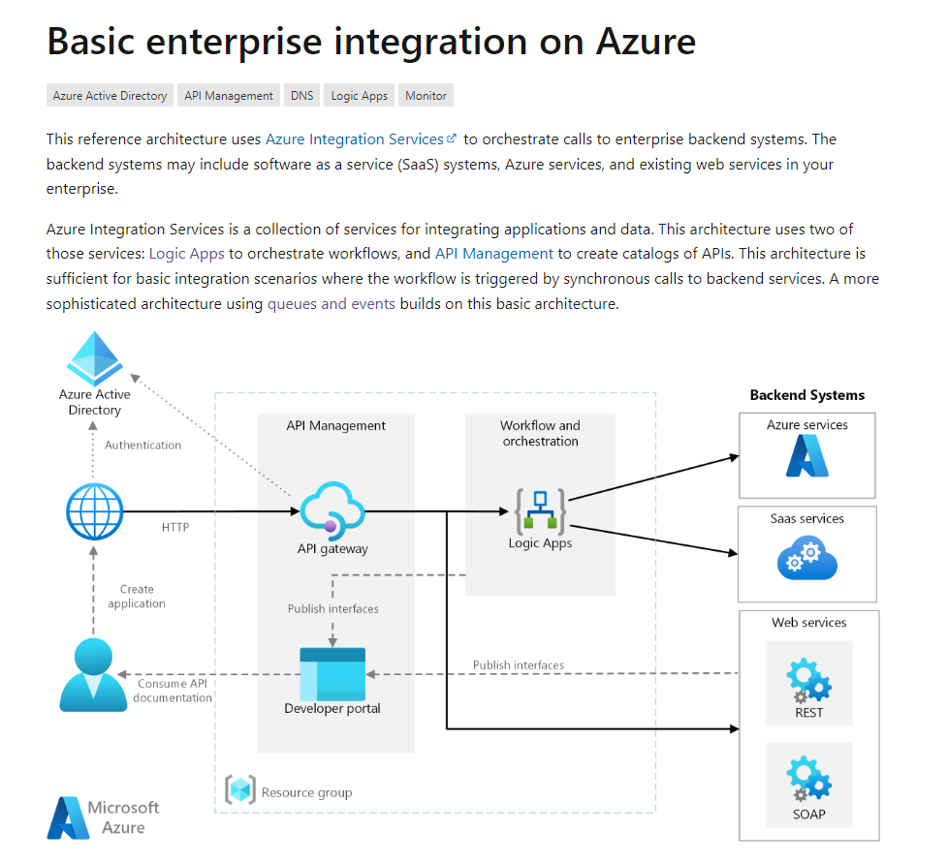

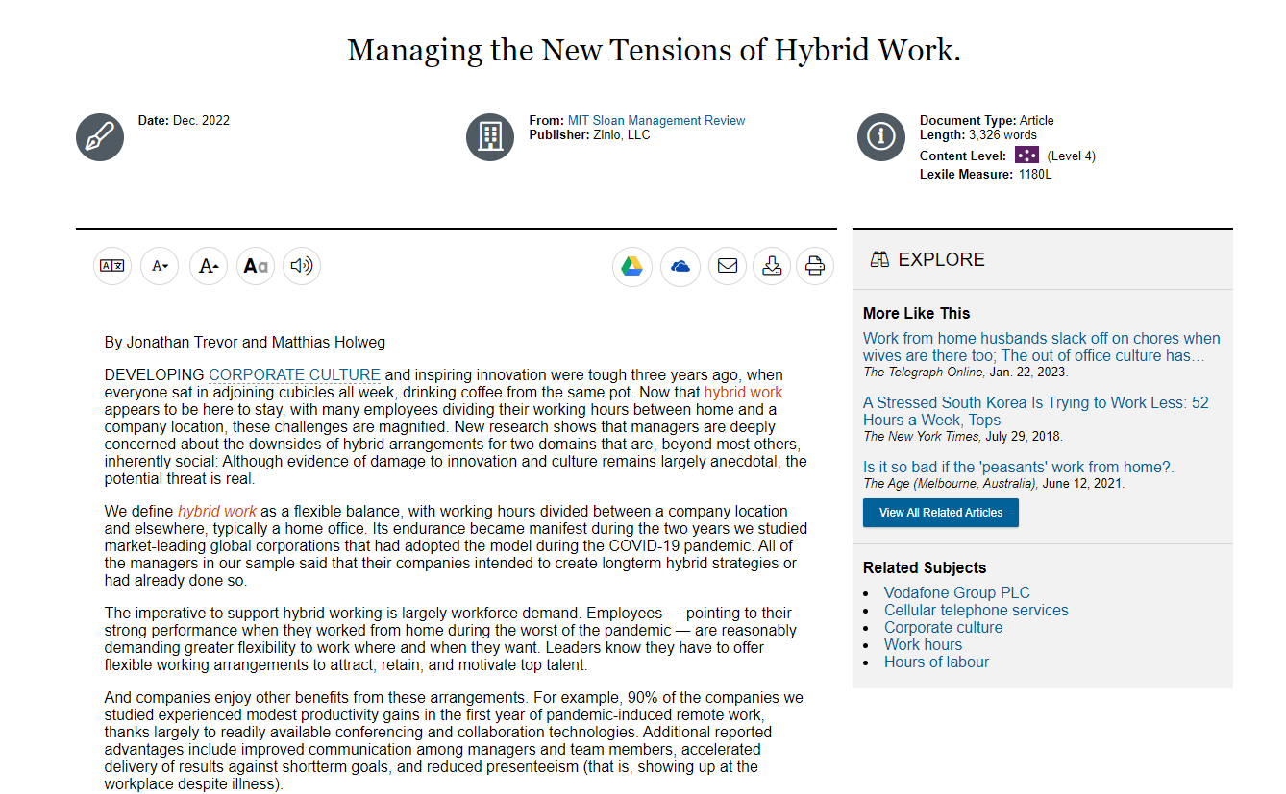

Appendix C: Excerpts from traditional sources
Source# 1: Technology-enabled remote work and changing work norms are making it easier for people to change roles or employers without uprooting themselves.¹ But technology may play another role in employee mobility by making their contributions more visible. Our research shows how increased performance visibility can impact turnover.
Now that organizations are using digital collaboration tools like Slack, Microsoft Teams, Zoom, HubSpot, and Salesforce extensively, individual-level contributions and talents are gaining visibility. These tools don’t just facilitate the work itself; they also capture who does what and how it’s done, giving managers a clearer view of how teams work.² They also make it easier for remote workers to connect with mentors and others in their organization who can help them grow and advance.
Those recent developments intersect with another trend that’s been around a bit longer: Through online conferences, courses, publications, and online platforms such as LinkedIn and Substack, people can widely share and promote their expertise in many formats — articles, podcasts, videos, newsletters, tutorials, live coaching sessions, virtual presentations, and so on. The content they generate serves as marketing for their employers, but it also builds their professional reputations. And that, too, enhances visibility and mobility — not just for superstars, but for a much larger cohort of workers.
At the time of this writing, quit rates are on the rise.³ This is a critical moment — employers are bleeding talent, yet they don’t know how to address it. They’re keen to understand why people are leaving and to better meet their needs, and that’s wise. However, doing all that requires deeper insight into mobility itself — what constrains it, how visibility unlocks it, and the questions it raises for employers battling attrition. That’s what we’ll discuss here.
Source# 2:
The Developer's Guide to Azure is designed for developers and architects who are embarking on their journey into Microsoft Azure. In this guide, you will learn how to get started and choose services that are appropriate for your scenarios. From creating websites, databases, and desktop and mobile applications, to integrating the latest technologies into your application, Azure does the heavy lifting for you. Azure services are designed to work together so you can build complete solutions that last for the lifetime of your application. Whether you are just starting out, writing code for fun, or a professional developer, developing with Azure puts the latest cloud technology and best-in-class developer tools at your fingertips. You can easily build for the cloud in your favorite language. Azure provides a broad range of services that enable you to build rich applications and solutions so you can focus on apps, not infrastructure.

